The Verb ‘Tener’ Notes
- Tener = To have
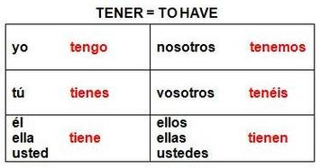
- Ex.
  - Tengo –I have
  - Tenemos – We have

